1. Grade Checker
Take a score as input and print the grade based on the following:
90+ : "A"
80-89 : "B"
70-79 : "C"
60-69 : "D"
Below 60 : "F"
here we used a basic if else statement to carry out marks and all.

GitHub link: https://github.com/MAKKY013/TuTeDude_Assignment-1_Python-and-Bash_Grade-Checker.git

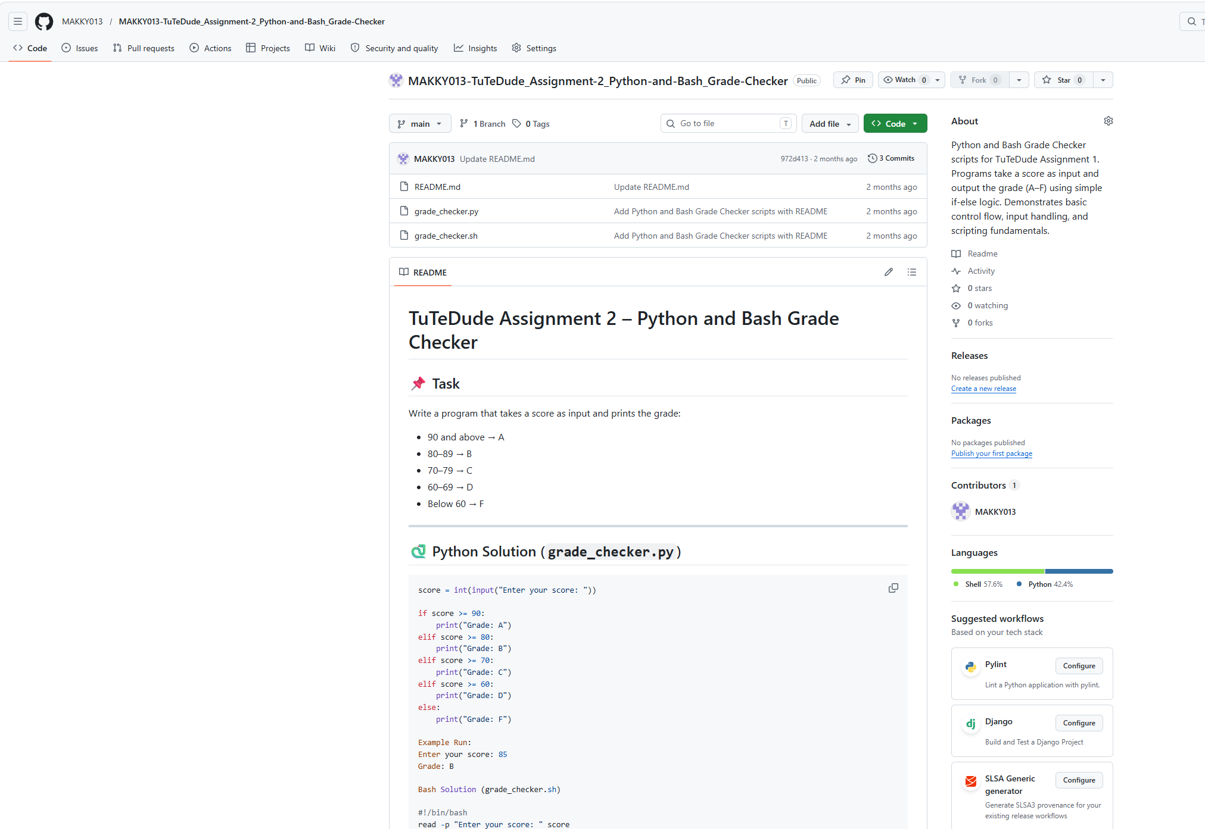

2. Student Grades
Create a dictionary where the keys are student names and the values are their grades. Allow the user to:
- Add a new student and grade.
- Update an existing student’s grade.
- Print all student grades.
Used dictionary and basic operations. Using if else:

Link: https://github.com/MAKKY013/MAKKY013-TuTeDude-Assignment-2-Python-and-Bash-Student-Grades.git

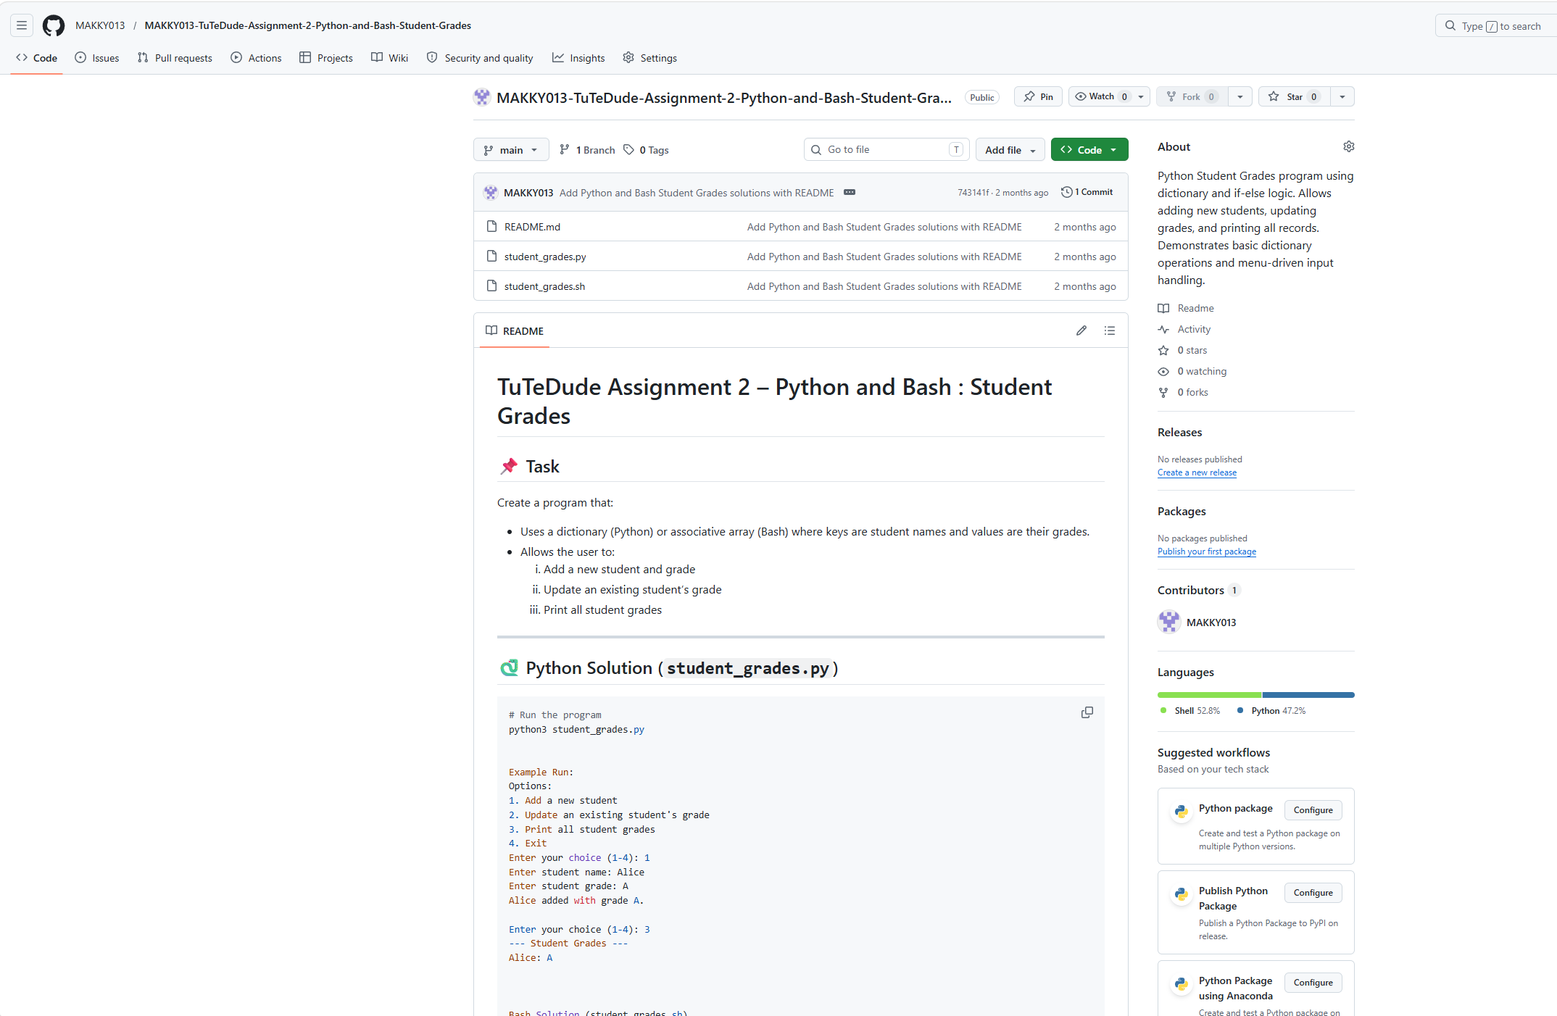

3.Write to a File
Write a program to create a text file and write some content to it.
Using file functions like write and open.

Link: https://github.com/MAKKY013/TuTeDude-Assignment-2-Python-and-Bash-Write-to-a-File

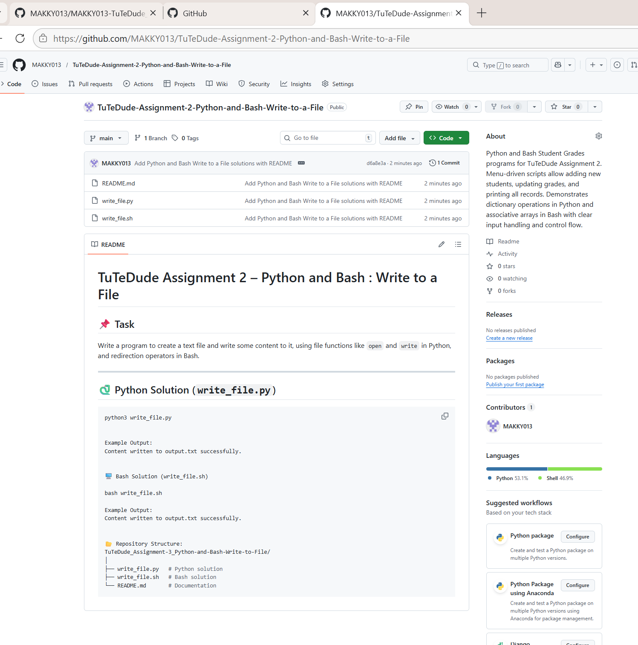

4. Read from a File
We used open in read mode and file.read to read and print to display.

Link: https://github.com/MAKKY013/TuTeDude-Assignment-2-Python-and-Bash-Read-from-a-File/tree/main

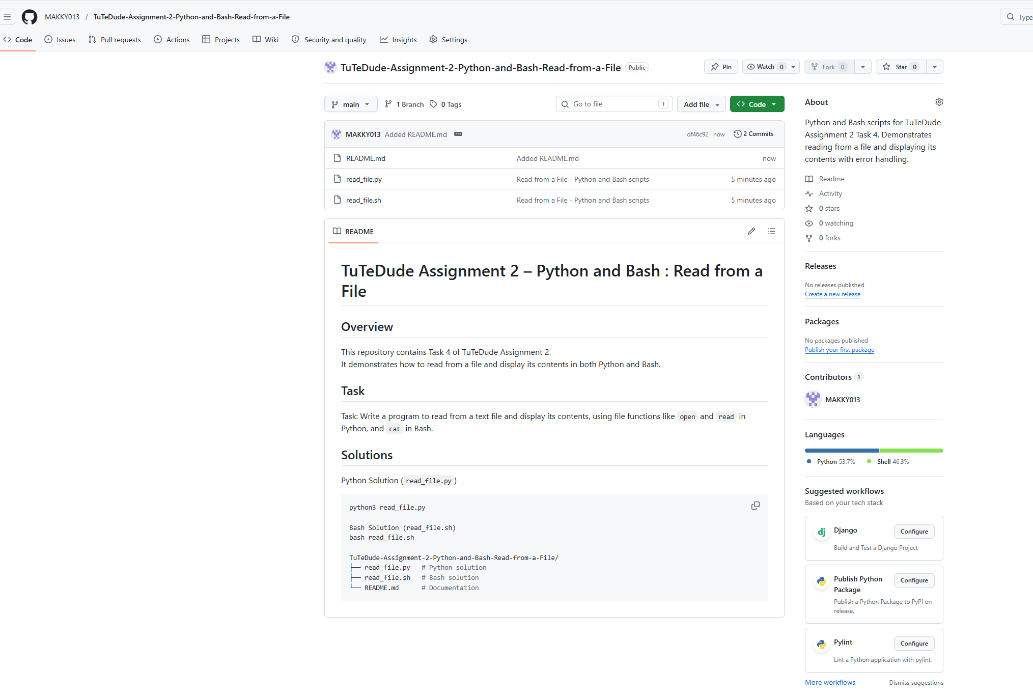

Submission Guidelines -: Attach Screenshots or command along with explanation and submit in doc(google doc or microsoft doc) format or share github link

